1. Provide a screenshot showing that you successfully ran the docker network create command to create the Docker network called myCDCNetwork.



1. Provide a screenshot to show that the Activity14_3 folder in VS Code.

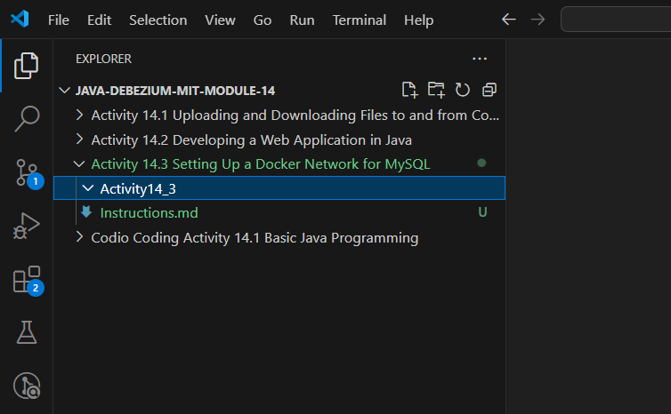

1. Provide a screenshot to show that you added the customer.sql file.

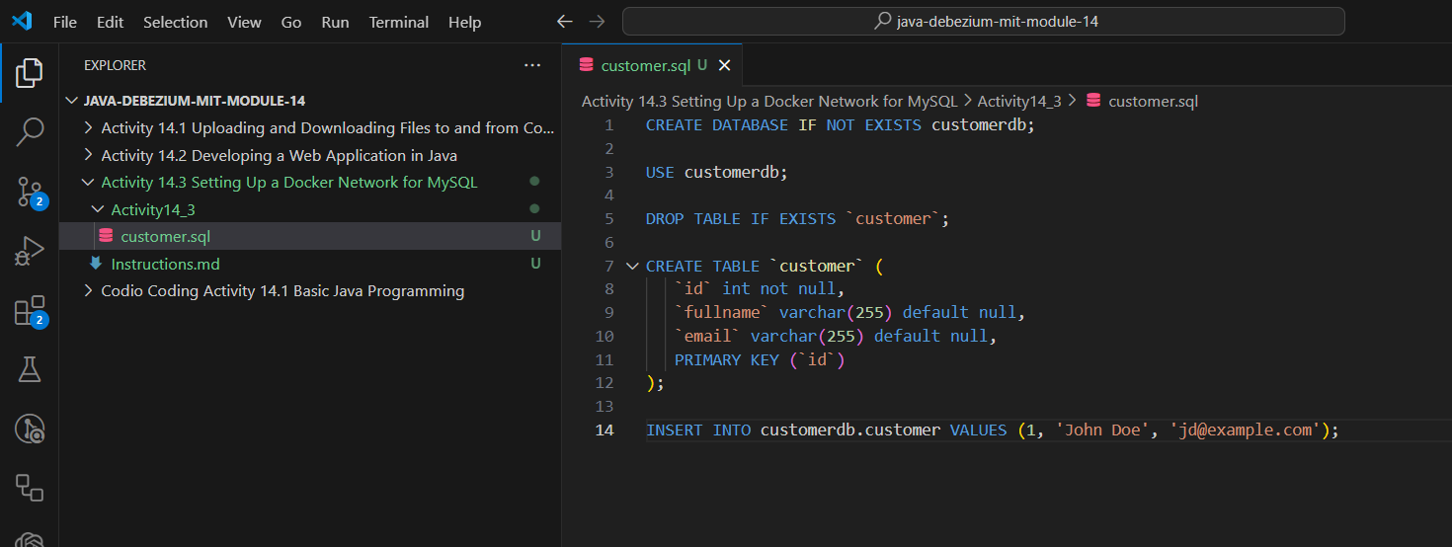

1. Provide a screenshot to show that you successfully added the file called Dockerfile.

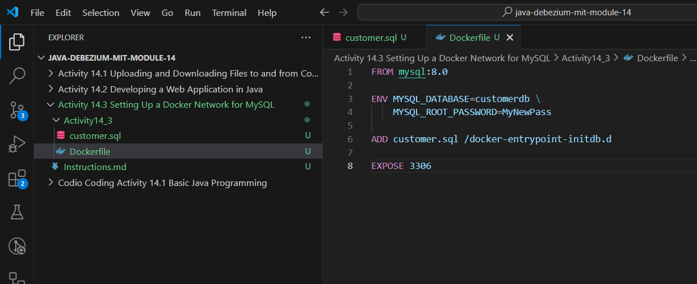

1. Provide a screenshot to show that there are no Docker *containers* running.

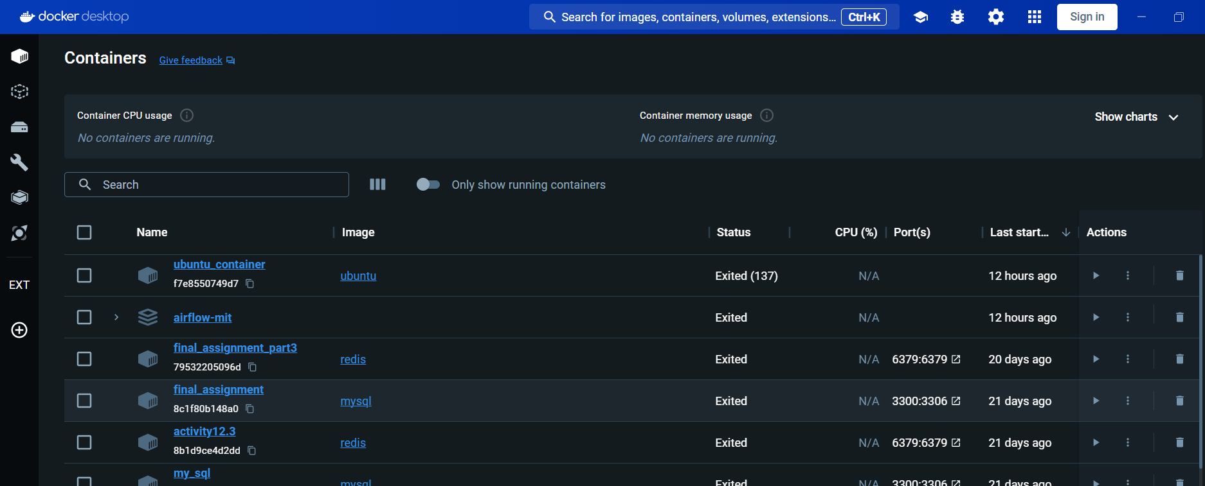

1. Provide a screenshot to show that you successfully executed the command to create a MySQL Docker *image*.

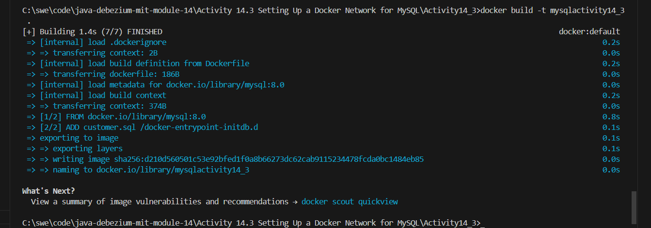

1. Provide a screenshot to show that you successfully executed the command to create a MySQL Docker *container* and associate it to the myCDCNetwork.

I have to change the port because I already have MySQL locally



1. Provide a screenshot of your Docker Desktop showing the mysqlserver *container* running.

